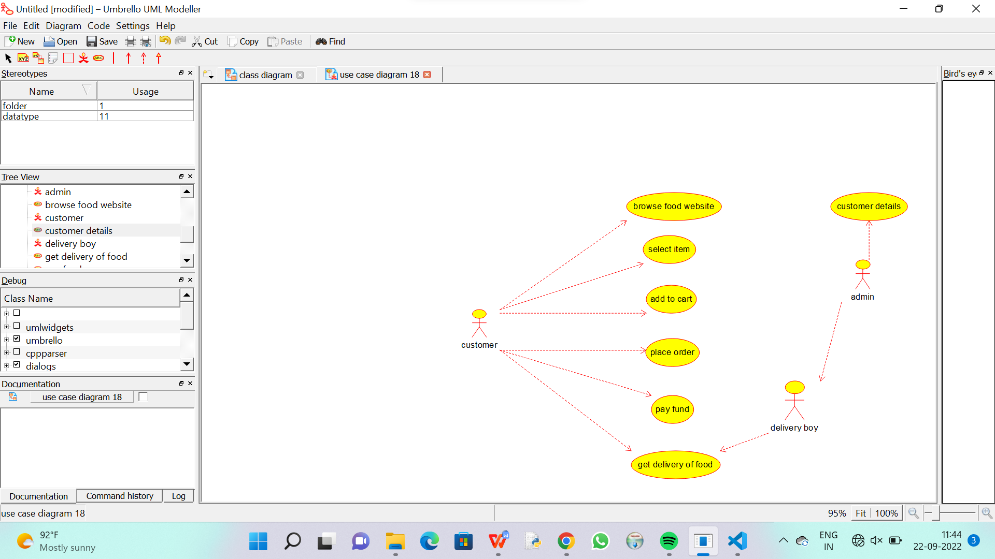

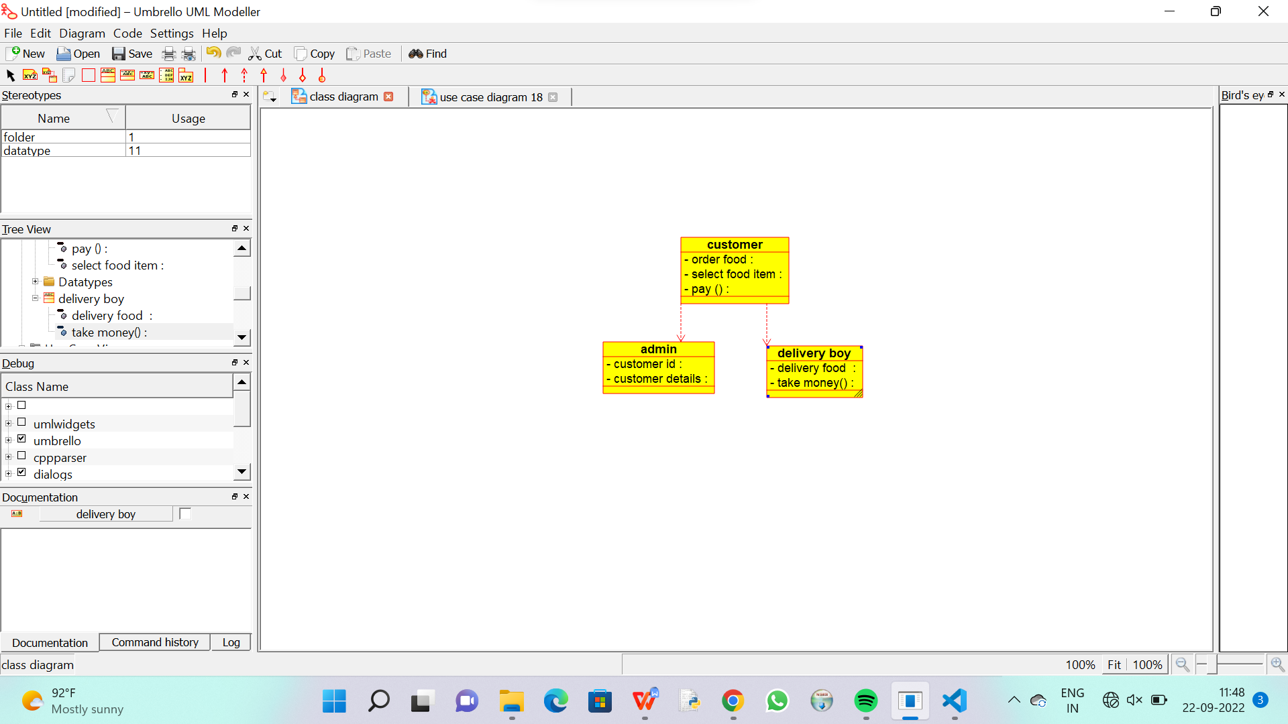

CODE FOR DELIVERY BOY:

/**

 * Class delivery_boy

 */

public class delivery_boy {

  //

  // Fields

  //

  private void delivery_food_;

  private void take_money_;

  //

  // Constructors

  //

  public delivery_boy () { };

  //

  // Methods

  //

  //

  // Accessor methods

  //

  /**

   * Set the value of delivery_food_

   * @param newVar the new value of delivery_food_

   */

  private void setDelivery_food_ (void newVar) {

    delivery_food_ = newVar;

  }

  /**

   * Get the value of delivery_food_

   * @return the value of delivery_food_

   */

  private void getDelivery_food_ () {

    return delivery_food_;

  }

  /**

   * Set the value of take_money_

   * @param newVar the new value of take_money_

   */

  private void setTake_money_ (void newVar) {

    take_money_ = newVar;

  }

  /**

   * Get the value of take_money_

   * @return the value of take_money_

   */

  private void getTake_money_ () {

    return take_money_;

  }

  //

  // Other methods

  //

}

CODE FOR CUSTOMER:

/**

 * Class customer

 */

public class customer {

  //

  // Fields

  //

  private void order_food;

  private void select_food_item;

  private void pay_;

  //

  // Constructors

  //

  public customer () { };

  //

  // Methods

  //

  //

  // Accessor methods

  //

  /**

   * Set the value of order_food

   * @param newVar the new value of order_food

   */

  private void setOrder_food (void newVar) {

    order_food = newVar;

  }

  /**

   * Get the value of order_food

   * @return the value of order_food

   */

  private void getOrder_food () {

    return order_food;

  }

  /**

   * Set the value of select_food_item

   * @param newVar the new value of select_food_item

   */

  private void setSelect_food_item (void newVar) {

    select_food_item = newVar;

  }

  /**

   * Get the value of select_food_item

   * @return the value of select_food_item

   */

  private void getSelect_food_item () {

    return select_food_item;

  }

  /**

   * Set the value of pay_

   * @param newVar the new value of pay_

   */

  private void setPay_ (void newVar) {

    pay_ = newVar;

  }

  /**

   * Get the value of pay_

   * @return the value of pay_

   */

  private void getPay_ () {

    return pay_;

  }

  //

  // Other methods

  //

}

CODE FOR ADMIN :

/**

 * Class admin

 */

public class admin {

  //

  // Fields

  //

  private void customer_id;

  private void customer_details;

  //

  // Constructors

  //

  public admin () { };

  //

  // Methods

  //

  //

  // Accessor methods

  //

  /**

   * Set the value of customer_id

   * @param newVar the new value of customer_id

   */

  private void setCustomer_id (void newVar) {

    customer_id = newVar;

  }

  /**

   * Get the value of customer_id

   * @return the value of customer_id

   */

  private void getCustomer_id () {

    return customer_id;

  }

  /**

   * Set the value of customer_details

   * @param newVar the new value of customer_details

   */

  private void setCustomer_details (void newVar) {

    customer_details = newVar;

  }

  /**

   * Get the value of customer_details

   * @return the value of customer_details

   */

  private void getCustomer_details () {

    return customer_details;

  }

  //

  // Other methods

  //

}